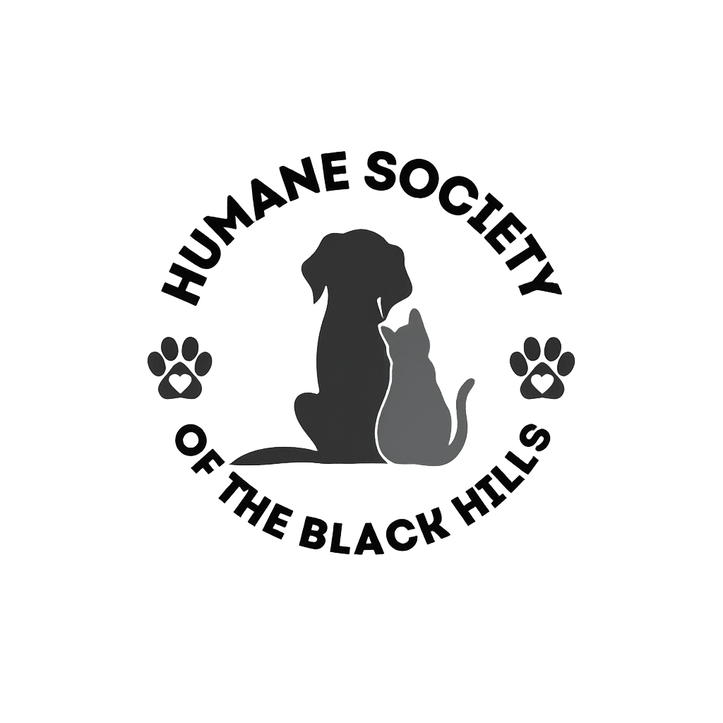
ANIMAL SERVICES & ENFORCEMENT

Licensing Standard Operation Procedure
In order to be in compliance with Rapid City and Pennington County Licensing Ordinances, kennels and some animal related businesses are required to obtain a new license annually.
The license must be purchased at the Humane Society of the Black Hills, prior to being approved and must have been signed off by either a City Zoning Inspector or a County Zoning Inspector. Rapid City businesses will be required to pay a non-refundable licensing fee prior to Animal Services and Enforcement conducting inspection. In order for the license to be approved, the applicant must have a signature from either of these departments prior to Animal Services and Enforcement inspecting the property and signing the license.
Once the license is issued, Animal Services and Enforcement will issue a Certificate of License with an issue date and expiration date on the certificate, which the business must keep on hand and accessible on the property as validation of license.
Listed below is a step-by-step process that must be taken by license applicant when applying for a Rapid City Kennel/Animal Related Business License:
___1) License Application must be obtained by applicant from the Humane Society of the Black Hills located at 1820 E. St. Patrick Street; Rapid City, SD 57703, or online at www.hsbh.org with the non-refundable license fee paid to the Humane Society of the Black Hills. Businesses that require multiple licenses will pay for the primary license and a reduced amount for each subsequent license. (Fee schedule attached). A certificate will be given to the business owner for each license.
___2) Applicant must complete application fully and truthfully.
___3) Applicant must contact the City Zoning Inspector to come assess the building which is listed on the application and will be the facility in which the animals will be housed to ensure the facility meets all building code requirements.
___4) Following the inspection of premise with the signature of approval from the designated City Zoning Inspector, the applicant must contact Animal Services and Enforcement at 605-394-4132 or come to the Animal Services and Enforcement Office located at 1820 E. St. Patrick Street; Rapid City, SD 57703, to request an inspection from Animal Services and Enforcement, which will inspect the premise fully to ensure that the facility is proper for animals and poses no threat to any animals which will be housed at said facility. Animal Services and Enforcement Officer conducting the inspection of premise will complete a “New License Checklist”.
___5) Following the Animal Services and Enforcement inspection of premise, with signature of approval by the inspection Animals Services and Enforcement Officer, the license will be issued.
___6) Following the issuance of the License to the applicant, a Certificate of License will be issued to the applicant, which must be kept on the premise of the licensed property and accessible at all times, as it is the proof and validation of the License.
___7) License holders must renew the license/s annually by December 31, as the license expires for the entire duration of the business being in operation.
___8) License holders must also always maintain standards of humane treatment and maintain sanitary conditions and operate within Rapid City Ordinance.
___9) A license holders’ failure to abide by regulations set forth by Rapid City Ordinance may result in a citation.
ANIMAL SERVICES & ENFORCEMENT
Inspection Checklist

AS & E Officer: ___________________________________________ Date & Time: ________________________
ORDINANCE: 6.08.050 ORDINANCE: 6.08.052

Kennel License
It is unlawful for any person to operate a kennel as defined in this title without first obtaining a license for the kennel. Only one license is required per one kennel. To apply for a license, a person desiring to operate a kennel shall pay an application fee.
Licenses will be issued by the City’s Designated Animal Control Authority provided the use is in compliance with the city zoning ordinances and animal control ordinances. No kennel license may be issued until the property has been inspected by an Animal Control Officer and the Animal Control Officer has reported to the City’s Designated Animal Control Authority, in writing, that the kennel meets the requirements of all city ordinances, state statutes and is being operated in a humane manner. Kennel licenses shall be issued for 1 year beginning January 1.

Kennel License Checklist
Proper shelter and protection for weather (heat, cold, rain, and other related conditions). Yes m No m
IF NO: (REASON) __________________________________________
At least once a day food free from contamination
Yes m No m
IF NO: (REASON) __________________________________________
At least once a day water free from contamination
Yes m No m
IF NO: (REASON) __________________________________________
Nutrition meets the normal daily requirements for condition and size of dog or cat. Yes m No m
IF NO: (REASON) __________________________________________ Proof of veterinarian services if needed. Yes m No m
Veterinarian name/number _________________________________ Sanitation procedures proper for purpose? Yes _{m} No _{m}
IF NO: (REASON) __________________________________________

Pet Daycare License
It is unlawful for any person to operate a pet daycare as defined in this title without first obtaining a license for the pet daycare. Only one license is required per one pet daycare. An application fee to apply to operate a pet daycare shall be established by resolution of the Common Council of the City. Licenses will be issued by the city’s designated animal control authority provided the use is in compliance with the city zoning ordinances and animal control ordinances. No pet daycare license may be issued until the property has been inspected by an animal control officer and the animal control officer has reported to the city’s designated animal control authority, in writing, that the pet daycare meets the requirements of all city ordinances, state statutes and is being operated in a humane manner. Pet daycare licenses shall be issued for 1 year beginning January 1.

Pet Daycare License Checklist
Proper shelter and protection for weather (heat, cold, rain,
and other related conditions). Yes m No m
IF NO: (REASON) __________________________________________ At least once a day food free from contamination for
number of days in stay Yes m No m
IF NO: (REASON) __________________________________________ At least once a day water free from contamination for
number of days in stay Yes m No m
IF NO: (REASON) __________________________________________
Nutrition meets the normal daily requirements for condition and size of dog or cat. Yes m No m
IF NO: (REASON) __________________________________________ Proof of veterinarian services if needed. Yes m No m
Veterinarian name/number _________________________________ Sanitation procedures proper for purpose? Yes _{m} No _{m}
IF NO: (REASON) __________________________________________

ORDINANCE: 6.08.054 ORDINANCE: 6.08.056

Pet Grooming Business License
It is unlawful for any person to operate a pet grooming business as defined in this title without first obtaining a license for the pet grooming business. Only one license is required per one pet grooming business. To apply for a license, a person desiring to operate a pet grooming business shall pay an application fee. An application fee to apply to operate a pet grooming business shall be established by resolution of the Common Council of the City. Licenses will be issued by the city’s designated animal control authority provided the use is in compliance with the city zoning ordinances and animal control ordinances. No pet grooming business license may be issued until the property has been inspected by an animal control officer and the animal control officer has reported to the city’s designated animal control authority, in writing, that the pet grooming business meets the requirements of all city ordinances, state statutes and is being operated in a humane manner. Pet grooming business licenses shall be issued for 1 year beginning January 1. Hospitals, clinics and other premises operated by a licensed veterinarian for the care and treatment of animals are exempt from the provisions of this section.

Pet Grooming Business License
Property inspected by Animal Control Yes m No m
IF NO: (REASON) __________________________________________
Animal Control Officer reported to City Yes m No m
IF NO: (REASON) __________________________________________
One Year term for care and treatment Yes m No m
IF NO: (REASON) __________________________________________ Proof of veterinarian services if needed. Yes m No m
Veterinarian name/number _________________________________ Sanitation procedures proper for purpose? Yes _{m} No _{m}
IF NO: (REASON) __________________________________________

Pet Store License
It is unlawful for any person to operate a pet store as defined in this title without first obtaining a license for the pet store. Only one license is required per one pet store. To apply for a license, a person desiring to operate a pet store shall pay an application fee. An application fee to apply to operate a pet store shall be established by resolution of the Common Council of the City. Licenses will be issued by the city’s designated animal control authority provided the use is in compliance with the city zoning ordinances and animal control ordinances. No pet store license may be issued until the property has been inspected by an animal control officer and the animal control officer has reported to the city’s designated animal control authority, in writing, that the pet store meets the requirements of all city ordinances, state statutes and is being operated in a humane manner. Persons operating the pet store are not required to license individual animals as provided in this title. Pet store licenses shall be issued for 1 year beginning January 1. Hospitals, clinics and other premises operated by a licensed veterinarian for the care and treatment of animals are exempt from the provisions of this section.

Pet Store License
Application Fee Yes m No m
IF NO: (REASON) __________________________________________
Animal Control designated Compliant with City Ordinance
Yes m No m
IF NO: (REASON) __________________________________________
Refer to Veterinarian or City/State Attorney for specific information.

License Application
NOT TRANSFERABLE

The undersigned makes application for a License under the provisions of Rapid City Ordinance __________________ or Pennington County Ordinance -1. Article V, Section 2, Licensing of Kennels for a period ending Month/Day/Year __________________________________ .

Name of Applicant: ________________________________Social Security or Tax I.D. No. ______________________
Home Address: ______________________________________________ Telephone No.: ______________________ Business Name: ________________________________________________________________________________ Business Address: ___________________________________________ Telephone No.: ______________________ If partnership, the name and address of each partner: _________________________________________________
If a corporation, the names and addresses of the officers: ______________________________________________ Description of the activity to be carried on under such license: __________________________________________ ______________________________________________________________________________________________ Number of animals to be housed at this location at any given time: ______________________________________
Number of animals six months or older owned by applicant: ____________________________________________
Application made this ____________________________ day of _________________________________________
CONTACT PERSON
Name: ________________________________________________________________________________________
Address: ______________________________________________________________________________________ Applicant shall annually update information with the Humane Society of the Black Hills. v
Signature of Applicant: ___________________________________________________ ______________________ Approved by ___________________________ Animal Control _________________________________________
Approved by ________________________ City/County Zoning _________________________________________
(City/County Zoning signature required before Animal Services and Enforcement inspection)
The Humane Society of the Black Hills is under no obligation to refund license application fees if denied

